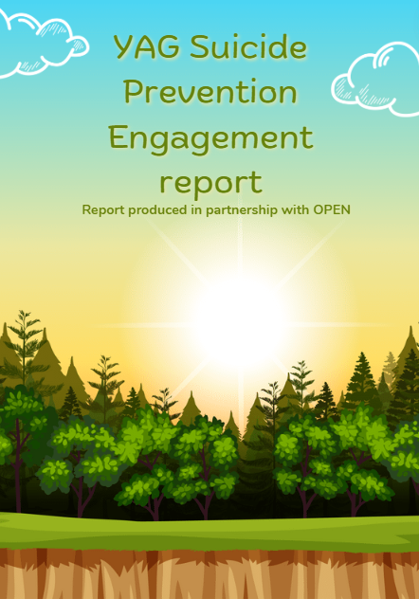

Contents

**OPEN’s Background 2**

**Background to project 2**

**Methodology/Approach 2**

**Participant data (numbers, gender split, etc) 3**

**Participant data: 3**

**Key findings 3**

**YAG Priorities – 12**

**Conclusion and any recommendations: 14**

**Feedback from young people after the sessions 15**

## **OPEN’s Background**

OPEN is a youth led charity with ten years’ experience of working with our community in a bottom up approach to support our young people to learn and grow together.

Children in Scotland commissioned OPEN to carry out engagement work surrounding YAGs priorities and produce a report with the views from young OPEN volunteers. These sessions were led by Shannon, Peer Research Development Worker, and Jess, Organisation Development Lead. Shannon used her peer research experience to plan and deliver the engagement work using peer research and facilitation methods. Jess has a background in both youth work and mental health support, she used her knowledge to inform how sessions would be run in a safe and appropriate way.

## **Background to project**

Alongside her role as Organisation Development Lead, Jess has been volunteering with the Suicide Prevention Youth Advisory Group for the last year. This is a topic Jess has been passionate about, particularly ensuring the voices of rural young people in Scotland are heard as there are different challenges that young people face in rural communities. Jess is supported by Una, Project Coordinator, to carry out this role. From this involvement it was identified that OPEN and Children in Scotland could work together to engage with young people from Shetland to find out a bit more about how they felt in regards to suicide prevention in Scotland, this felt like a good opportunity to have this conversation with OPEN volunteers as mental health repeatedly comes up as a top priority for young people in Shetland.

## **Methodology/Approach**

The engagement methods used were:

* Participation exercises including creative methods
* Online tools such as mentimeters, survey monkey and padlet
* Group work

OPEN’s approach was to use good youth work practice founded in peer to peer engagement. To work with participants at a level they felt comfortable, creating an informal and supportive environment to ensure the wellbeing of participants throughout this work. This included providing refreshments, regular breaks and light hearted ice breakers and energisers at the start and end of sessions. Participants were offered additional support throughout the sessions and follow up support is still available. This approach was to ensure young people felt supported during the sessions and to create safe spaces if they felt the engagement was too much. At the start of the first session we made a group agreement together to ensure the space was safe and supportive for everyone, making a plan for if anyone needed space or to disengage in the session.

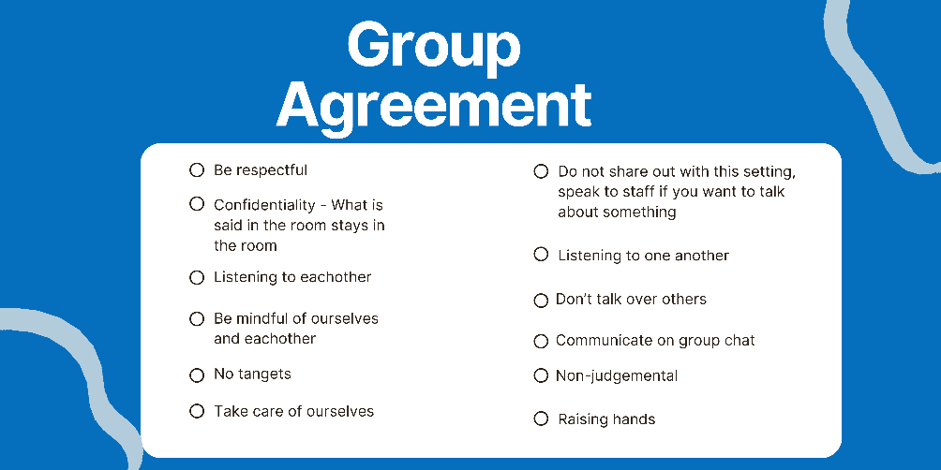

OPEN staff did not receive any feedback around running the session differently for the second session.

## **Participant data (numbers, gender split, etc)**

OPEN staff communicated with volunteers both online and in person prior to the engagement sessions. Staff spoke to volunteers during the weekly Peer Education meeting to go over the purpose of the engagement sessions and explain what the sessions would look like. Staff shared information sheets about the sessions on the OPEN group chat for young people to digest out with the meeting spaces to ensure participants could make informed decision if they wanted to take part.

There was a total of two engagement sessions over the course of two weeks. Sessions were two and a half hours long with comfort breaks during the session, there was also a ‘safe space’ available throughout sessions where people could speak with a supporting adult out with the group setting, and the young people were provided with the option to debrief with staff after the session and suppled with a signposting sheet if anyone wanted to access additional support.

### **Participant data:**

A total of 12 young people took part in the work with a split of six females and six males.

Age range of participants ranged from 15 to 25, please refer to the bar graph below.

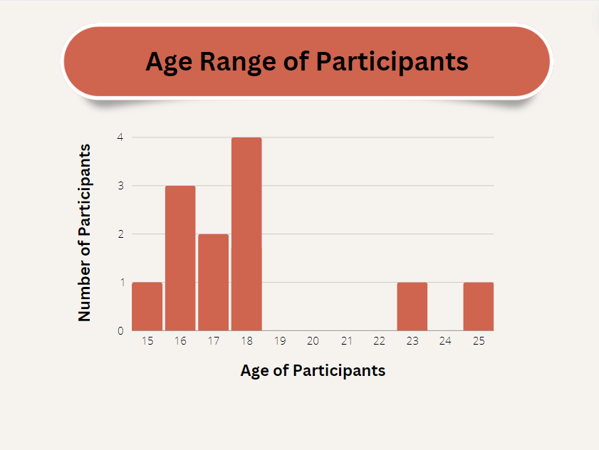

## **Key findings**

In this section, we will explore the key findings gathered during the engagement sessions. Exploring different topics such as informal and formal support and mental health support around suicide prevention. A case study was shared which enabled participants to dig deeper into support needs of individuals and identify when and what services could be required to provide support. YAG’s priorities are also included in our key findings; participants chose their top three and added feedback to their top three priorities.

**Different types of support**

In this section we discussed the below questions as a group, looking at different levels and types of support and how the young people felt about them in relation to suicide prevention. Young people identified the importance of being present with someone when they are struggling, there was a variety of peer to peer support methods that young people identified, recognising the importance of listening. Young people put emphasis on hollistic support and not just relying on medication. Although young people also idenifited that some medication can be really benefical, but that it is just one part of the puzzle and that everyones mental health journey is very individual, participants discussed needing to be ready to accept help and being in the ‘right place’ in their lifes to work with professionals. However on the flipside of that young people feel as though there is a lack of support services within Shetland that are available to them.

**How do we informally support people?**

* By listening
* Being physically present
* Physical touch
* Empathy
* Confidence boost
* Remove from bad settings (distractions)
* Telling bad jokes
* Give advice
* Spending time with them even if you are just sitting with them
* Sitting quietly together
* Being their calm person
* Letting them know that they are loved

**How do we safely support our friends or peers?**

* Sometimes you just need to sit with someone and say real
* Taking care of yourself first, you can’t help someone else if you are not okay
* Report to people if a disclosure has been made and someone is in danger (contact OPEN, Duty Social worker)
* Realise that you can’t fix every situation
* Don’t feed self-destructive habits
* Sign posting
* Taking on training
* Don’t overestimate how much help someone needs

**Do we think generally people are doing informal support safely or does more need to be done around this?**

* More needs to be done – most people don’t know when someone’s struggling
* Destigmatised
* Don’t feed into unhealthy habits or thoughts
* Difference between men and women – identifying the differences
* Not everything is fixed by drugs (including prescription drugs)
* Mental health services are so poor that informal support can be damaging when the shortfall is on each other
* Boundaries – safe guard yourselves, you can’t fix everything (not your responsibility)
* More up to date information to cater to today’s problems
* Holistic support
* CAHMS push folk out too quickly people are presenting even worse and presenting back to the service due to support ending too quickly prior
* Training around at what point it is concerning

**Does high-level mental health and wellbeing support aid in preventing suicide?**

* Depends on the person
* I think it can help but it really depends on the person
* I think it can but you need to get a good person
* If person centred and if the person want to and is ready to get better
* Yes it can be very crucial if the person receiving support is ready and accepting that they need the support
* Yes if not forced (person needs to want support)
* Things like mental health hospitals NO
* Creative therapy is the best
* Therapy helps when you want it
* Prescriptions drugs no, should be a tool to sedate people
* Personally, I think that they could if they went about it the right way. Like you wouldn’t put an introvert in a room full of people and tell them to start talking about their problems

**Does low level mental health and wellbeing support aid in preventing suicide?**

* I think maybe in some cases but maybe not as well as other aid
* Depends on the person
* No because I think they aren’t qualified enough – but they can refer you to more qualified people
* Not if someone’s mental health gets worse
* Yes for some people more casual support is all they need as higher level can seem more intimidating
* Yes since it feels more casual
* Sometimes?
* Can be more helpful, feels less medical can be more comfortable
* Training can vary, person may not be qualified
* Can be lower stakes (texts, walks)
* Yes, initially
* Gateway
* Every little helps
* Yes everyone has it somewhere
* Even from non – professionals
* Support can go very far
* Again it depends on the person and the circumstances of the issue

**Do young people identify mental health support can aid in preventing suicide?**

* It could (if there was any)
* No
* Speaking to people is good but it has to be a qualified nice person
* Yes
* I think it depends on the kind of support
* Sometimes? X 2
* Therapy has to be useful and engaging
* If use distractions
* Yes it can aid as it can provide coping mechanisms but may not always fully prevent it
* Therapy has to be catered to the person
* People have to want help
* Awareness is important
* Awareness
* Education can help people understand
* Especially in rural areas, confidentiality is everything
* It’s safe to talk about it. Social service, police, hospitals want to be told or involved if you tell a counsellor or therapist
* It all can but all levels it also can’t help (diagnosis / neglect / stigmatised )
* I think that some young people (some of them) might just think that none of it will help due to what other young people say about it

**Scenario Group work feed back**

We came up with a made up scenario describing a friendship between a 17 year old ‘Jane’ and 16 year old ‘Sarah’. Sarah had a history of suicidal thoughts but had received support and recovered. Jane started to notice some warning signs that progressively got worse, offering peer support to her friend, though when Jane mentions speaking to an adult about it Sarah does not want this. We asked the young people to read through the scenario in groups and answer some questions. During this part of the session young people recognised when the scenario had gotten to the stage where external support was needed. Young people felt that Jane could have supported Sarah to talk to her parents or another trusted adult. It was clear within this section that young people did have a clear understanding of where the line between peer support and professional support lies. Young people also talked about Jane telling someone how much Sarah was struggling which sparked discussion about this perhaps leading to undesirable outcomes for Sarah.

**Could Jane have done anything differently?**

• She could have recommended other support (if she knew of any)

• Tell someone

• Reassure Sarah that she is loved and reassure her life is more important than whatever her parents are dealing with. They both go to the parents who get her better support. Suggest I can speak to people for her

• Signpost to other agencies

• She could’ve encouraged her to speak to her parents or look for further help / support

• She could’ve done worse – with the knowledge she has, she did well

**Was there any points you think Jane could have gotten extra support?**

• She could have recommended other support (if she knew of any)

• Could have reassured her that telling her parents wasn’t a bad thing.

• Could contact trusted adult for advice

• Speak to Child line

• Jane could get support from her family or friends

• Jane could’ve gotten her support without naming her. – outcomes could have been undesirable for Sarah

**Do you think at any point it became clear this was not just Jane’s responsibility?**

• Highlighted in paragraph ‘Sarah called Jane one night in tears, she said that she felt so done, she did not want to continue on anymore and felt like everyone would just be better off without her. Jane spoke with her on the phone, reassuring her that she was not a burden and that she was loved. They spoke for a while and Jane managed to get Sarah back to being calm. Jane tried to encourage Sarah to speak to her parents but Sarah started to become anxious, she asked Jane to promise not to tell anyone because she did not want to worry everyone with her problems and wanted to just try and get better herself.’

• When she starts talking about not wanting to continue.

• Yes

• The last paragraph

**Any other reflections?**

• Sarah could do with more professional help to be honest

**Local support and care**

**From a local context do you feel that there is the right support and care in place to support suicide prevention? (Asked on menti and answered individually)**

During this part of the session young people told us of the different types of support within Shetland. While there was a wide range of support within Shetland that young people knew of aswell as national charities the majority felt like there was not the right care or support in place in regards to suicide prevention. Young people felt that their access to support that is available is limited due to support services being at capacity. Young people feel while there is support available, that there is a disparties within this. Support not feeling like its right for them, men feeling the cultural pressure not to ask for help, lack of immediate crisis care, there is a need for support to be tailored to make care equitable and accessible. Young people spoke of peer support methods, self care and the different activites or external help that they use. While escapism was talked about participants generally felt that escapsim in this sense wasn’t harmful, or was the least harmful option for them to utalise in moments of crisis or when they are struggling.

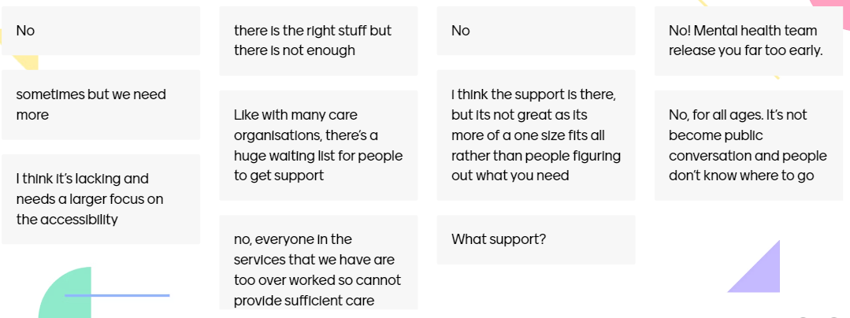

**Exploring support and care that is available in Shetland can you take a second to think about when things felt really difficult what would have helped? When things felt really difficult, who would you have turned to for help? (Asked in small groups)**

**Named services/professionals**

* Citizens Advice Buero
* Pupil support teachers
* CAMHS
* School nurse
* Samaratins – Quite good support
* Therapy

**Personal connections**

* Friends / family
* Friends
* Myself
* Chosen family
* My peers – most accessible / trust worthy
* My cat
* My dog

**Self-help**

* ADHD sensory toys
* Anxiety relef petting zoo (fluffy animals)
* Space to my self

**External help**

* Needs to be an actual place, drop in / self referal
* Not taken seriously by general public (Be taken more seriously by general public)
* More holistic care needed
* More training for low level support workers, promote these job roles
* Destigmatisation / more help for men
* Someone who is qualified and listens
* Reassurance
* Validation
* Better access to info about where to go

**What would have made you feel better?**

**Service provision**

* Community based options
* More frequent access to services
* More support within schools
* More in the moment ‘crisis’ care, less long term workshop type of work
* Medication
* More opportunities / things to do (in different locations)

**Self-help/activity based**

* Gym
* Sports
* Better sports access
* Writing down my feelings
* Meditating
* Yoga
* Going outside
* Taking an ice shower
* A bath
* Taking a warm / hot shower
* Feeling like you have more control

**Help from other people**

* People to ask more questions
* Ask young people whats helpful
* Validation
* Family
* Hug (just one)
* Being close- not necessarily touching
* Someone to listen without judgement
* A hug
* Somebody listening to you
* A friend
* Reassurance

**Help from external sources**

* Animals
* Food
* Nails
* STI teddy’s (Soft plushy toys)
* Fidget toys
* Phone
* Work that you love (volunteering and paid)
* TikTok
* Sex (with someone you love and trust)
* Cigarettes
* THC / CBD
* Alcohol
* Safe sex ( with a trusted partner/s)

**Creating the right conditions**

* Self expression
* Comfort
* Privacy

**Other**

* If it didn’t happen

**On Padlet we asked the group “What does good support and care look like?” They used text and pictures to answer this question.**

**From the answers it was clear that being a good listener, a person-centred approach and a supportive space are top priorities.**

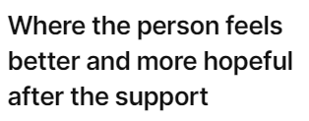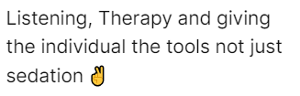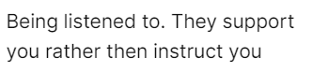

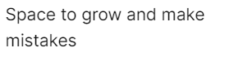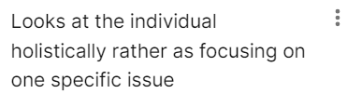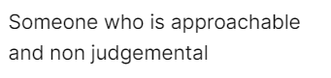

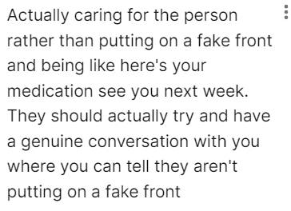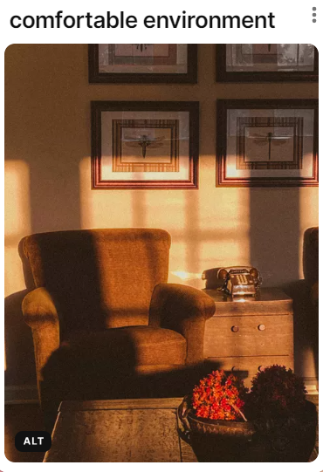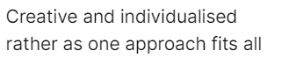

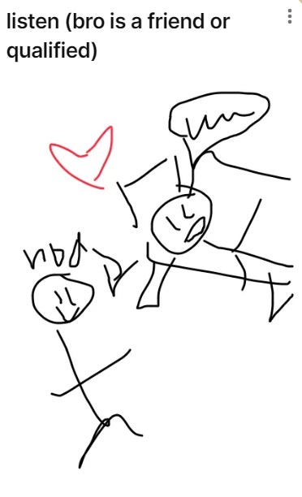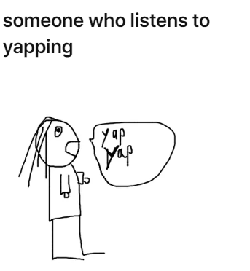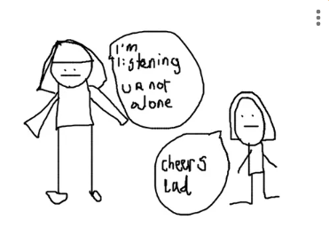

**The young people also shared some other ideas such as hobbies, nature or pets:**

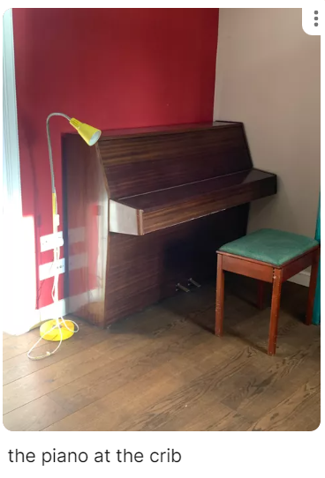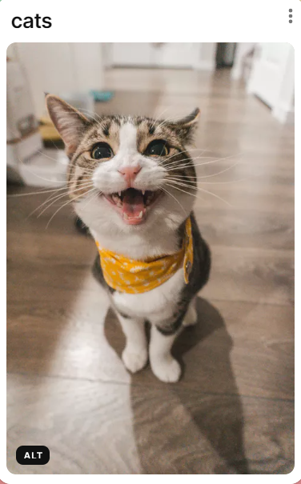

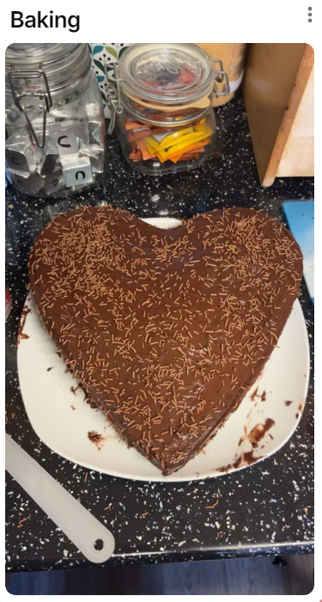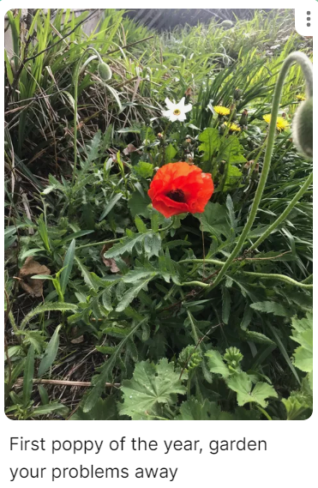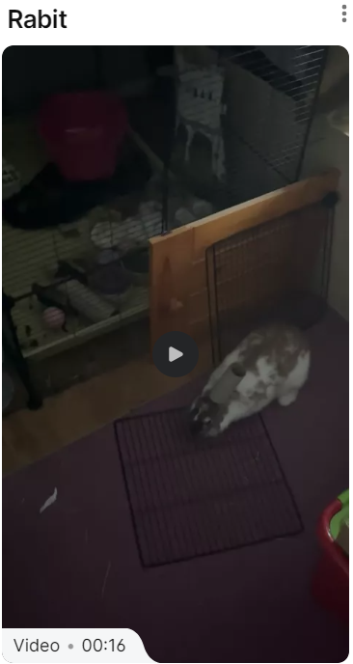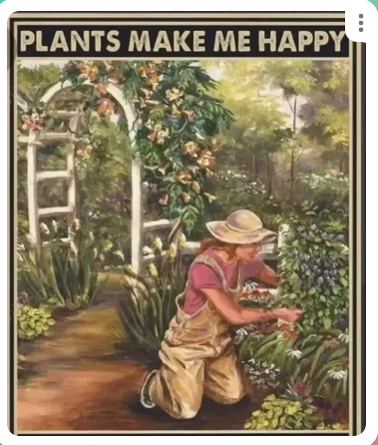

**There was also some criticism of the current support available**

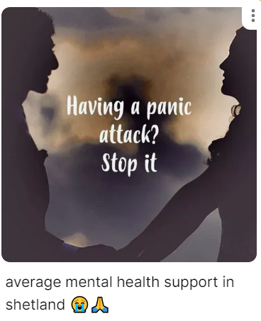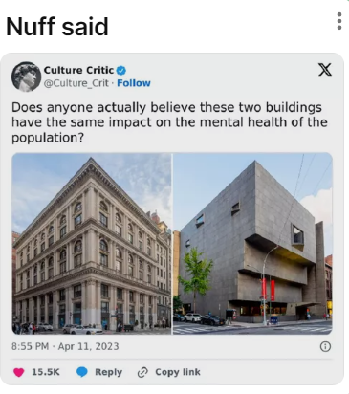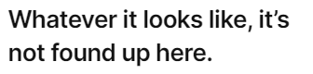

## **YAG Priorities**

## We asked the young folk to rate YAGs Sucide preventions groups priorities from their favourite to least favourite priorities. We used survey monkey to collate and rank the six priorties.

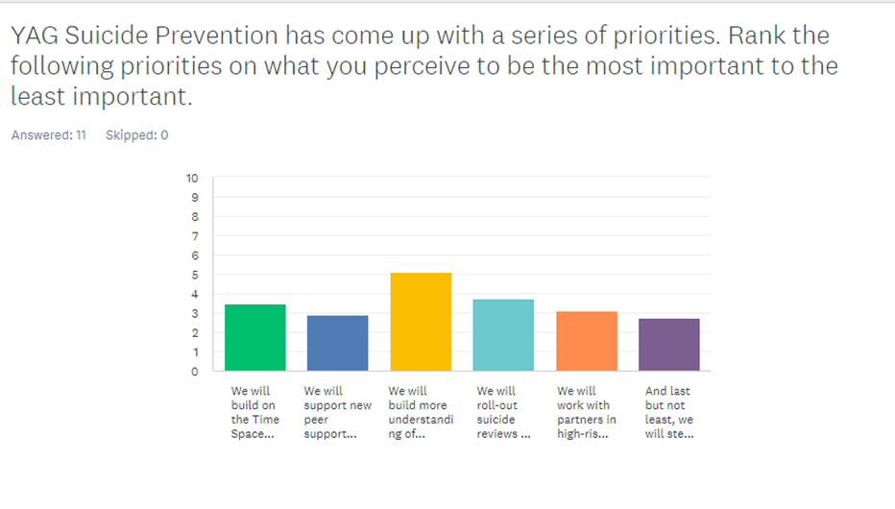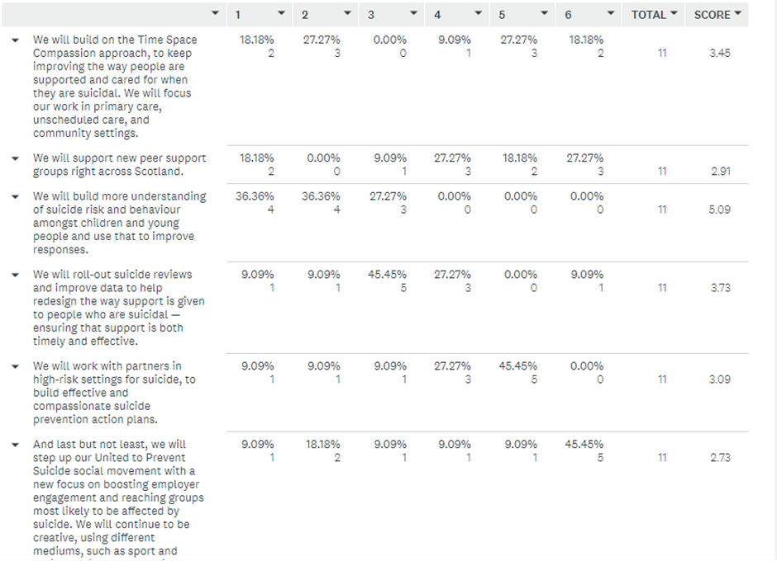

Shown above is the rating system we used, with 1 being the top priority and 6 being their bottom priority. The scoring along the right hand side of the table identifies the participant’s top three priorities.

The volunteers created posters surrounding the top three priorities. The information that was writen on each of the posters is shared below. Whilst creating the posters participants spoke highly about hollistic approaches to support, they highlighted the importance of seeing eachother through a compassionate human lense. Young people want services to come away from their tick box approach which can feel impersonal. Young people feel as though understanding of suicide risk and behaviour is really important so that they can provide peer support more effectively and so that everyone knows what to be aware of. Young people also spoke of the importance of spaces where they can use differently, comfortable spaces, spaces they know that they can break things or be destructive in ways that isnt damaging. The over arching conversation during this section had themes of support and self expression in many forms and that it is very individual how each person wants to be supported or help themselves.

**We will roll-out suicide reviews and improve data to help redesign the way support is given to people who are suicidal — ensuring that support is both timely and effective.**

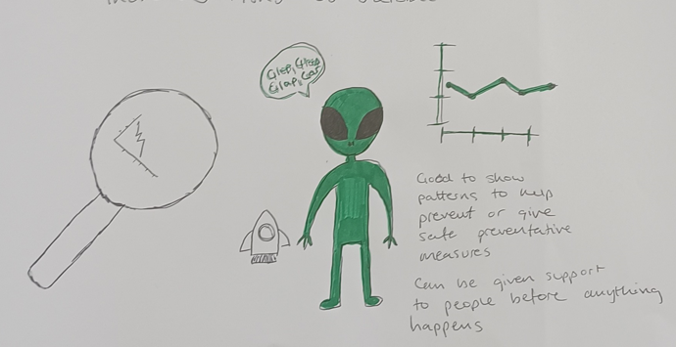

*We also had a conversation about the term ‘suicide reviews’ a few of the young people felt this term reminded them more of review of a service, asking people to rate their experience of suicide. We had a good discussion about what suicide reviews were and how they were used which lead us to the following points.*

“Ensure that this data is actually used to better suicide prevention”

“Use data to tackle issues in various social areas to crackdown on factors increasing risks of suicide”

“Good to show patterns to help prevent or give safe preventative measures”

“Can be given support to people before anything happens”

**We will build more understanding of suicide risk and behaviour amongst children and young people and use that to improve responses.**

“Services should ‘enleve le masque’ (take off their mask, the only thing I know in French lol)”

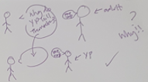“It seems like it should be a given”

“Services should take a person centred approach rather than ‘going by the book’”

“Strengths based approach”

“Services should look at a holistic approach rather as a tick box approach”

“Services should take a humanitarian approach to suicide prevention”

“We need input from young people’s experience”

“Empowerment”

“Helps get support quicker and take preventative measures”

“Young people can benefit more from peer support as they can relate better”

“If services aren’t catered to young people theres no point in making more X2”

“Individualised approach”

“Young people can help each other if they understand the situation better.”

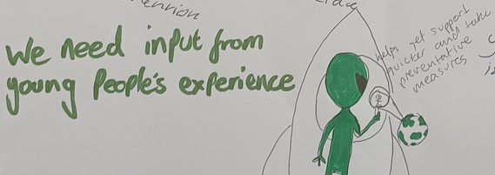“Positive affirmations”

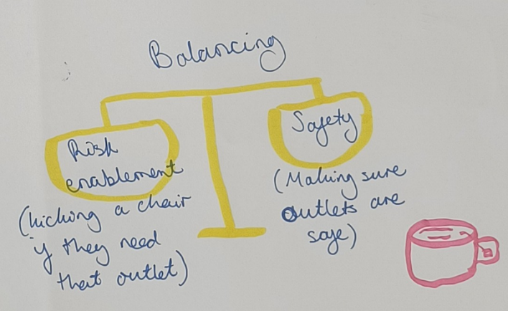**We will build on the Time Space Compassion approach, to keep improving the way people are supported and cared for when they are suicidal. We will focus our work in primary care, unscheduled care, and community settings.**

“Person centred

“Smash / wreck room

“Need constructive support

“Working with people affected

“Building a support system

“Holistic approach

“Physical space needed

“Comfortable space = more relaxed and more likely to talk

“Balancing: risk enablement (kicking a chair if they need an outlet) and safety (Making sure outlets are safe)”

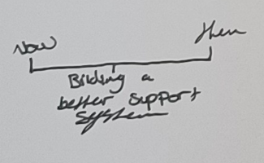

**Additional comments that have been added throughout the sessions:**

One week after the engagement sessions we checked in again with volunteers to offer follow up one to ones. As well as check ins with volunteers after meetings and sign posting information being shared. Volunteers did not ask for any follow up support after participating in sessions.

## **Conclusion and any recommendations:**

Reflections from young people seemed to surround themes like a lack of support within Shetland and that services appear to be at capacity, young people identified that there is not enough being done to support people with their mental health and wellbeing. This was highlighted through quotes like:

*‘Mental health services are so poor that informal support can be damaging when the shortfall is on each other’*

*‘More needs to be done – most people don’t know when someone’s struggling’*

*‘CAHMS push folk out too quickly. People are presenting even worse and presenting back to the service due to support ending too quickly prior.’*

Participants told us that they cannot provide care if they themselves arent okay and that *‘they cant fix every situation.*’ Recognising next steps that they could take if the situation got to the stage where they could no longer help pointing out that they could sign post or *‘Report to people if a disclosure has been made and someone is in danger (contact OPEN, Duty Social worker)’.*

While young people are aware of these they identifed the worry surrounding asking for help for themselves or their friends due to stigma. Implementing initiatives to reduce the stigma associated with seeking mental health support and making it easier for young people to ask for help without fear of judgement.

Young people also told us about the importance of care and the various ways that care is given, telling us that a range of hollistic care is needed to help someone struggling. Reflections from participants within the session when thinking about someone experiencing difficulties, the person needs to be ready to accept help and that it needs to be at a time that is right for them.

In conclusion, the current state of mental health services for young people in Shetland is inadequate and requires significant improvement. The feedback from young people indicates a pressing need for more comprehensive, accessible, and person-centered support services. An increase in services available to support young people struggling with their mental health, these services could provide a range of person centered and hollistic support.

Young people idenitifed that formal support tends to end to quickly which leads to them needing to use the service again due to a lack of support or feeling they were pushed from the service before they were ready. It was also identified that having the ‘right person’ to provide formal support plays a big part in whether they feel able to engage within a relationship. Services being able to work with someone that is right for them until they feel they are able independently support themselves would improve mental health. This recommendation is highlighted through quotes such as:

*‘Services should look at a holistic approach rather as a tick box approach’*

*‘Services should take a humanitarian approach to suicide prevention’*

Young people identifed that having a good support network is something that helps them. Creating the conditions where young people can build their support networks makes them feel connected and cared for when peer support is in place.

By addressing these areas, mental health services in Shetland can become more effective, compassionate, and responsive to the needs of young people. This would not only improve individuals personal experiences but also aid in building a healthier, more supportive community.

If you would like to hear what the wider Shetland community has to say around experiencing mental health, previous research conducted within Shetland. Similar themes such as support, self care and stigma are highlighted within the [Good Mental Health for All Report](https://www.healthyshetland.com/good-mental-health-for-all/#:~:text=Everyone%20has%20'mental%20health'%2C,all%20effect%20your%20mental%20health)

## **Feedback from young people after the sessions**

